Q4. Read the following program description and the explanation of the pseudo-language syntax before answering the sub-question.

[Program Description]
This program reads a file of test scores, calculates each individual’s total score, and then prints out a table of the scores, starting from the highest total. If two or more individuals have the same total score, they are ranked according to their score on the Japanese test.

(1) The format of the file that contains the test scores is as follows. The maximum number of records is 99.

Name | Japanese | Mathematics | English

(2) The printing format for the table of the scores is as shown below.

Test Score Table
 | Name | Japanese | Mathematics | English | Total
 | John Arrow | 100 | 96 | 95 | 291
 | Mary Brown | 96 | 91 | 100 | 287
 | Ed Collin | 95 | 98 | 94 | 287
 | Frank Kelly | 93 | 90 | 95 | 278
 | … | … | … | … | …

[Explanation of the Pseudo-Language Syntax]
Syntax and example | Explanation
① Program name: Create.  ① Procedure: Input (a, b).  ① File: Master.  ① Integer: Scores, points [3].  ① Record: Class  (String: A. Integer: B.). | Declares the program name, procedure, file, variable names, types, etc. The value shown in brackets (“[ ]”) indicates the number of elements in an array. If the type is identical, names can be listed, separated by commas. For a record that consists of several variables, write the name of the record and then list the variable definitions within the parentheses.
 Number of cases←Number of cases+1．   Total [6] ← Test scores [5]・Japanese.   Input (A, B). | Describes one round of processing. The “←” indicates the assignment operation. When referencing the array elements, write an expression that represents the element number within the brackets (“[ ]”). The number for the first element is “1.” When referencing a variable within a record, write the record name in the format “Class •A”, followed by a dot (“•”), and then the variable name. End the description of one step of processing with a period (“.”). “Input (A, B)” is a procedure call.
① If “condition” then   Processing 1. ...  — Else   Processing 2. ...  ② | This executes “Processing 1. ...” when “condition” is true, and executes “Processing 2. ...” when “condition” is false.  If there is no specific processing to be performed when "condition" is false, the “Else” portion is omitted.
 While “repeat condition” repeat the following.   Processing 1. ...   | This repeats “Processing 1. ...” while “repeat condition” is true.
{Comment} | This is a comment.
Comment: ‘Japanese’ should be replaced by the name of the languge used in your country.
[Program]
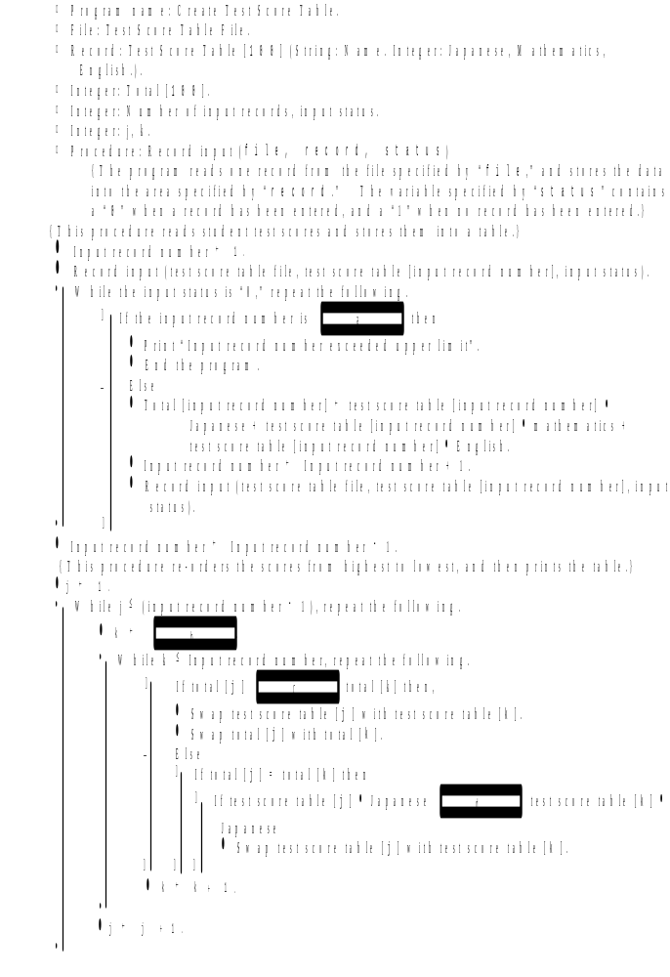

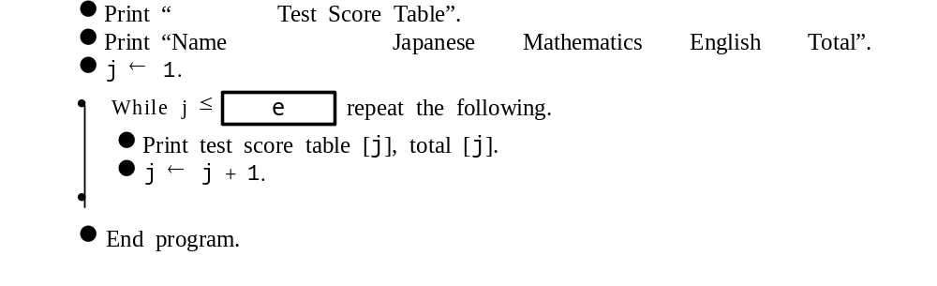

Sub-Question
Select the correct answers to be inserted into the corresponding boxes () in the above program from the choices provided below. Any of the choices may be selected more than once.

Answer group for a, b, and e:
a) (j − 1) b) (j + 1) c) 1
d) 2 e) 99 f) 100
g) 101 h) (Input record number − 1) i) Input record number
j) (Input record number + 1)

Answer group for c and d:
a) = b)B ≠ c) > d) <

